**DATABASE MANAGEMENT SYSTEMS ASSIGNMENT**

**ER DIAGRAM** :-

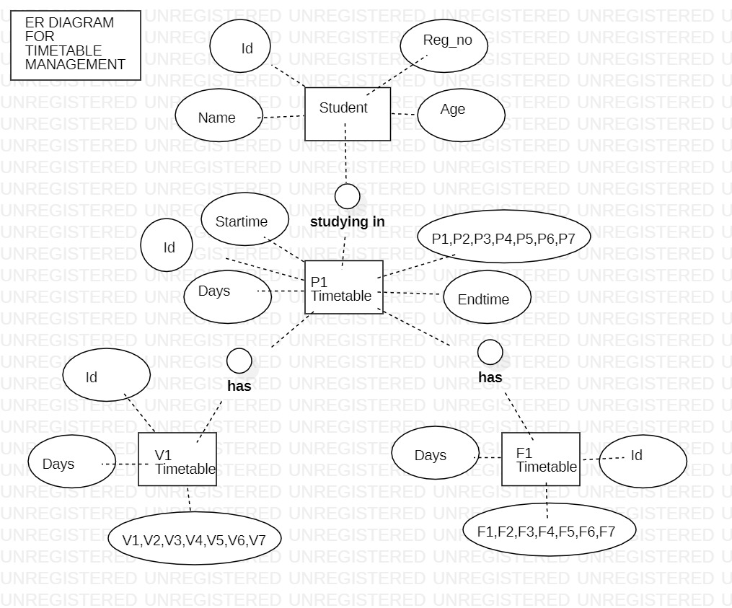

**RELATIONAL TABLE FOR ER DIAGRAM**:-

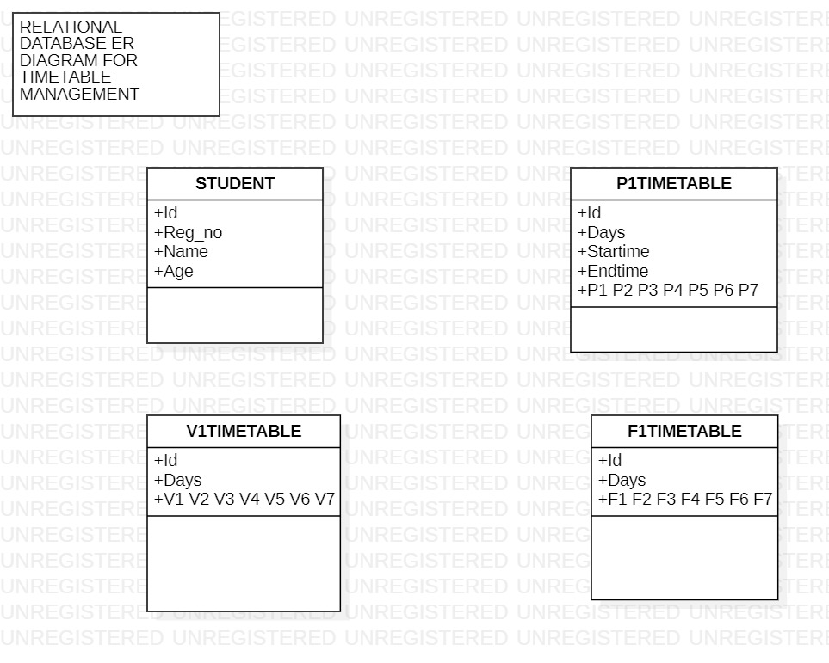

**SQL TABLE :-**

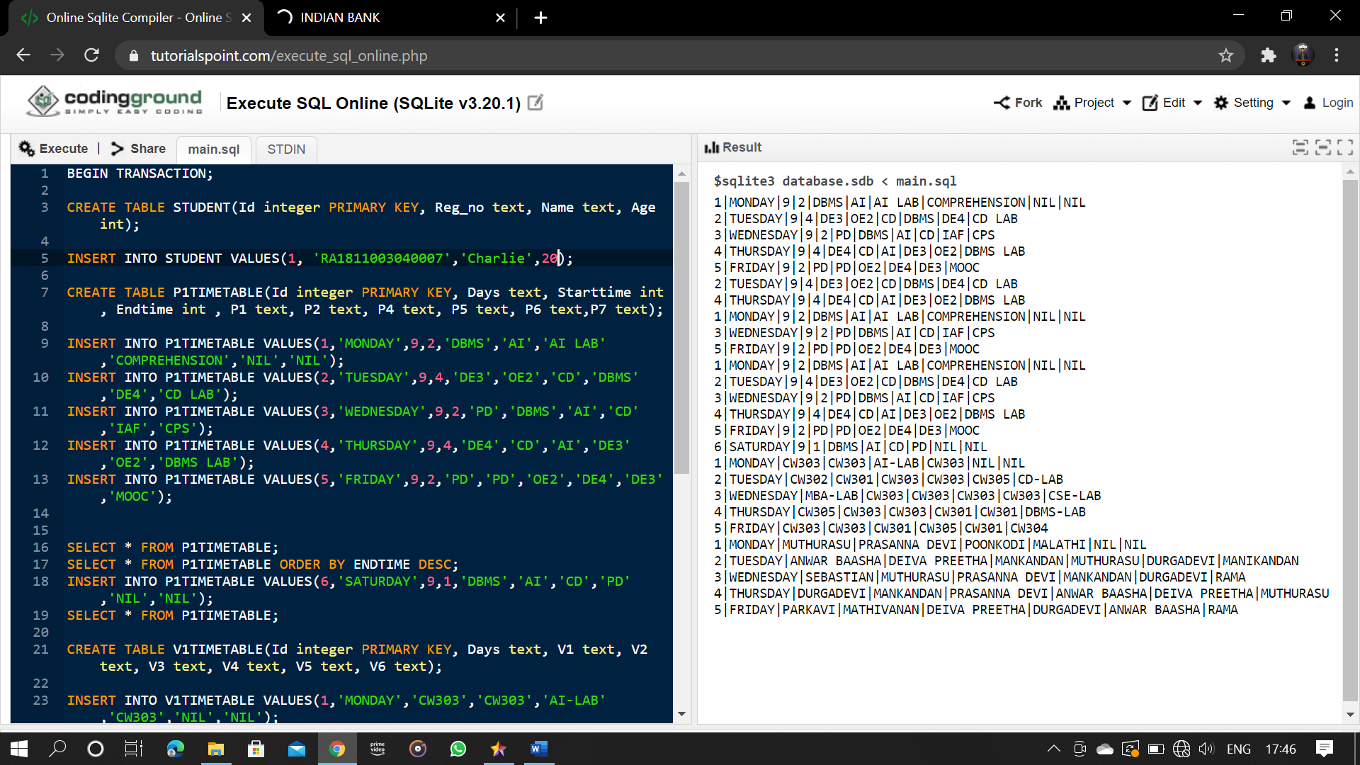

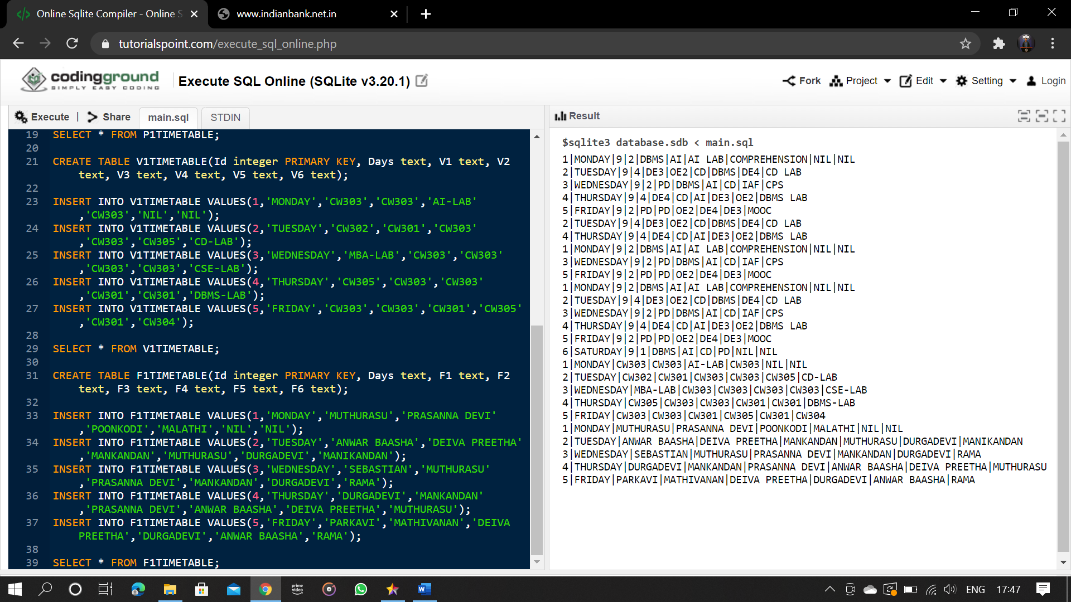

**SQL CODE :-**

BEGIN TRANSACTION;

CREATE TABLE STUDENT(Id integer PRIMARY KEY, Reg_no text, Name text, Age int);

INSERT INTO STUDENT VALUES(1, 'RA1811003040007','Charlie',20);

CREATE TABLE P1TIMETABLE(Id integer PRIMARY KEY, Days text, Starttime int , Endtime int , P1 text, P2 text, P4 text, P5 text, P6 text,P7 text);

INSERT INTO P1TIMETABLE VALUES(1,'MONDAY',9,2,'DBMS','AI','AI LAB','COMPREHENSION','NIL','NIL');

INSERT INTO P1TIMETABLE VALUES(2,'TUESDAY',9,4,'DE3','OE2','CD','DBMS','DE4','CD LAB');

INSERT INTO P1TIMETABLE VALUES(3,'WEDNESDAY',9,2,'PD','DBMS','AI','CD','IAF','CPS');

INSERT INTO P1TIMETABLE VALUES(4,'THURSDAY',9,4,'DE4','CD','AI','DE3','OE2','DBMS LAB');

INSERT INTO P1TIMETABLE VALUES(5,'FRIDAY',9,2,'PD','PD','OE2','DE4','DE3','MOOC');

SELECT * FROM P1TIMETABLE;

SELECT * FROM P1TIMETABLE ORDER BY ENDTIME DESC;

INSERT INTO P1TIMETABLE VALUES(6,'SATURDAY',9,1,'DBMS','AI','CD','PD','NIL','NIL');

SELECT * FROM P1TIMETABLE;

CREATE TABLE V1TIMETABLE(Id integer PRIMARY KEY, Days text, V1 text, V2 text, V3 text, V4 text, V5 text, V6 text);

INSERT INTO V1TIMETABLE VALUES(1,'MONDAY','CW303','CW303','AI-LAB','CW303','NIL','NIL');

INSERT INTO V1TIMETABLE VALUES(2,'TUESDAY','CW302','CW301','CW303','CW303','CW305','CD-LAB');

INSERT INTO V1TIMETABLE VALUES(3,'WEDNESDAY','MBA-LAB','CW303','CW303','CW303','CW303','CSE-LAB');

INSERT INTO V1TIMETABLE VALUES(4,'THURSDAY','CW305','CW303','CW303','CW301','CW301','DBMS-LAB');

INSERT INTO V1TIMETABLE VALUES(5,'FRIDAY','CW303','CW303','CW301','CW305','CW301','CW304');

SELECT * FROM V1TIMETABLE;

CREATE TABLE F1TIMETABLE(Id integer PRIMARY KEY, Days text, F1 text, F2 text, F3 text, F4 text, F5 text, F6 text);

INSERT INTO F1TIMETABLE VALUES(1,'MONDAY','MUTHURASU','PRASANNA DEVI','POONKODI','MALATHI','NIL','NIL');

INSERT INTO F1TIMETABLE VALUES(2,'TUESDAY','ANWAR BAASHA','DEIVA PREETHA','MANKANDAN','MUTHURASU','DURGADEVI','MANIKANDAN');

INSERT INTO F1TIMETABLE VALUES(3,'WEDNESDAY','SEBASTIAN','MUTHURASU','PRASANNA DEVI','MANKANDAN','DURGADEVI','RAMA');

INSERT INTO F1TIMETABLE VALUES(4,'THURSDAY','DURGADEVI','MANKANDAN','PRASANNA DEVI','ANWAR BAASHA','DEIVA PREETHA','MUTHURASU');

INSERT INTO F1TIMETABLE VALUES(5,'FRIDAY','PARKAVI','MATHIVANAN','DEIVA PREETHA','DURGADEVI','ANWAR BAASHA','RAMA');

SELECT * FROM F1TIMETABLE;